Potato Blight
Potato blight can occasionally infect crops on our allotments. Blight can also affect tomatoes which come from the same plant family. Blight in both potatoes and tomatoes will ruin your crops. The pathogen moves from the leaves to the potatoes and tomatoes and will spoil the actual tomatoes and potatoes. In the South of England blight can strike as early as the beginning of June. Blight attacks and spreads in warm, humid conditions called Smith Periods.
A full Smith Period occurs if, on each of 2 consecutive days:
- the minimum air temperature was at least 10C, and
- there was a minimum of 11 hours each day with a relative humidity of at least 90%
What Does Blight Look Like ?
Potato Blight
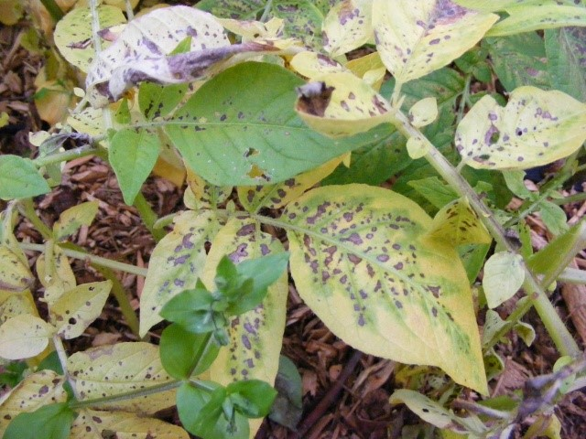
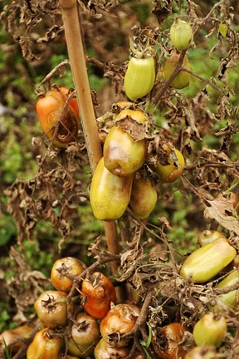
Tomato Blight
What to do if you get blight
Blight is difficult to manage. The key to dealing with any form of blight is to be vigilant and to act as quickly as possible when you find blight.
Your best course of action is to carefully remove and destroy the infected plant(s) and their immediate neighbours. Destruction should preferably be by burning or burying in a pit at least 60cm (2ft) deep. Blight is an obligate parasite, meaning that it can only survive in living plant tissue.
If you are not cultivating organically you can use a spray such as Bayer Fruit and Veg Fungicide or Vitax Bordeaux Mixture. This may slow up the progression of the blight but isn't a 'cure'. Bear in mind you are putting chemicals onto crops that you will eventually eat !
If you act swiftly you have a chance of saving at least some of your crop and you will avoid the infection spreading to crops on adjacent allotments.
How to Avoid Blight
What not to do
- Don't put old potatoes or potato leaves onto open compost heaps - that's asking for trouble !
- Don't save your potatoes from one year and then plant them as seed potatoes in the next season
- Don't use potatoes from the supermarket as seed potatoes
- Don't accept seed potatoes from other allotment holders unless you know they come from certified suppliers
- Don't plant your potatoes too close to each other. Blight thrives in close planted crops.
- Don't leave old potato tubers lying on the surface. Destroy old or damaged tubers by burning
What to do
- Buy your seed potatoes from certified suppliers
- When you harvest your potatoes make sure you don't leave any in the ground - even little ones !
- Plant your potatoes as early as possible (bearing in mind frost) as the UK has Late Variety Blight
- Earth up your potatoes
- Plant your potatoes at the recommended distance apart and not too close
- Burn rather than compost the potato leaves when you harvest your potatoes

