ALLOTMENT GARDENING
Cutteslowe Allotments

USING THE POLYTUNNEL

Cutteslowe Allotments Guide

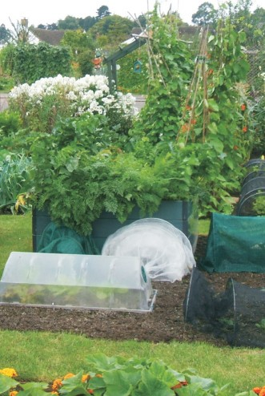
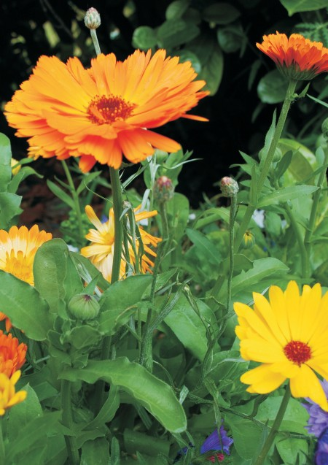
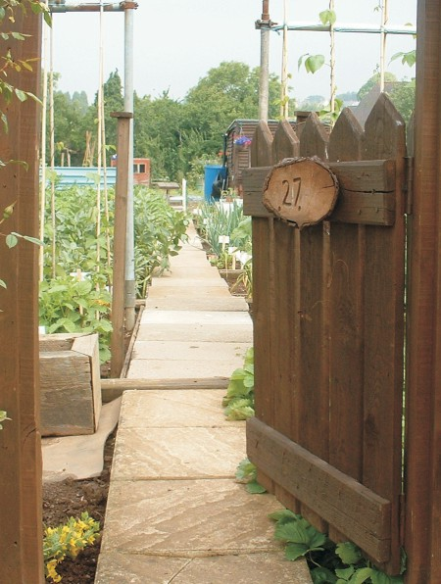
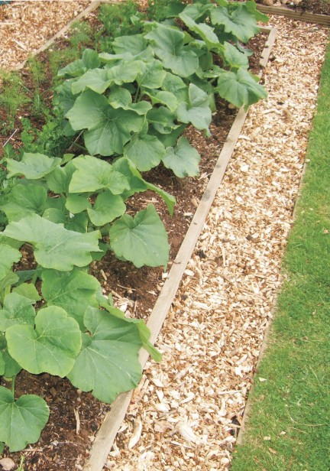
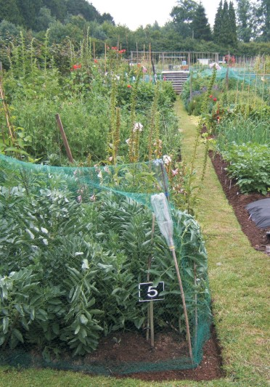
POLY-TUNNEL GUIDELINES

Security
Before putting plants in the poly-tunnel, please label your pots and trays with your name and plot number.

Remember what you do in here will affect other people’s plants. Infection thrives in these conditions. E.g. tomato blight can be rampant as well as Mildew and aphid infestation. The stronger your plants are, the less vulnerable they will be.

If your plants are diseased, mouldy, infested or dead they have to be removed or the Committee will remove them and notify the member responsible. No one wants to do this! So please keep an eye on them yourself to avoid problems, and consider not using the space if you can’t do this reliably.

Some recommendations and Good Practice
- Please don’t water other people’s plants unless specifically requested to.
- Do not leave the doors ajar for ventilation unless the weather is hot and close them when you leave the site!
- Feel free to remove snails, and weeds growing within the Poly-tunnel
- Water fully, rather than frequent dribbles. Don’t assume a plant needs watering every time. The tunnel can get very damp, especially in wet weather.
- Inspect your plants several times a week to check for moisture, rotting, moulds, pests, diseases. Remove the plant straightaway if you spot a problem.
- If you’re going away, or unwell, or just too busy to get down here, do find out if there is another plot holder who can keep an eye on your plants for you.
- Keep plants moving along, rather than have them sit here for months taking up room and providing a breeding ground for problems.
- Remove plants to your own plot when they are ready to go outside or to your compost.
- Poly-tunnel users should help to keep the water butts filled with Water as this will help maintain warm water for use and not check the plants using cold water from the dip tanks, especially during the colder months.
- Do not remove the Watering cans from the Poly-tunnel.

Growing in containers:

- Use potting compost rather than garden soil.
- Use clean containers, to reduce disease for your plants and other people’s.
- Remove any weeds so they can’t take hold in the compost – they will deplete your plants and potentially seed themselves in the tunnel.
- Remove all containers when they’re finished with or ask the committee for a possible storage place.

Help! If you are not sure about any issue in the Poly-tunnel, please contact the Committee via email or speak to a member.

