How to Build a Compost Bin from Wooden Pallets

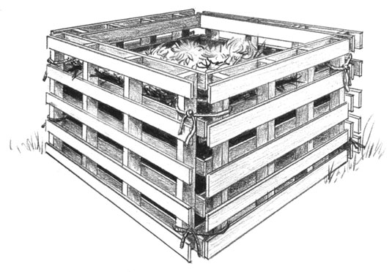
Building a Compost Bin from pallets is relatively straight forward and is a great way to deal with green waste on your site. It will provide you with good compost that you can then use to condition and enrich your soil.
- Level the ground where your bin will be.
- Set the pallets upright in a box shape.
- Lash the pallets securely together at the corners with wire, plastic or rope ties.
The front pallet acts as a hinged door, allowing you to access your compost by undoing the ties on one side and swinging it open. You can also remove the entire pallet to have wider access when adding or turning organic matter.
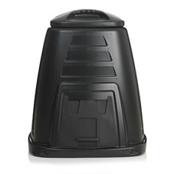
On half plots a simple plastic compost bin will take up less space and will give you enough capacity to deal with all your green waste over one season. Plastic Compost bins can be obtained for about £20 (see below)

220 Litre Plastic Composting Bin
Wilco £20

